Exercise:2

.Draw a coffe coffe day ordering system. A coffe coffee day shop vending machine

dispenses coffee to customers. Customers order coffee by selecting a recipe from a set

of recipes. Customers pay for the coffee using coins. Change is given back, if any, to

the customers. The ‘service assistant’ loads ingredients (coffee powder, milk, sugar,

water, chocolate) into the coffee machine. The ‘service assistant’ adds recipe by

indicating the name of the coffee, the units of coffee powder, milk, sugar, water,

chocolate to be added as well as the cost of the coffee. The service assistant can also

edit and delete a recipe. Develop the use case diagram for the specification above.

Aim:

The aim is to create a Use Case Diagram for a Coffee Day Ordering System where customers can order coffee from a vending machine by selecting a recipe, paying with coins, and receiving change. The Service Assistant manages the system by loading ingredients, adding, editing, and deleting recipes.

Procedure:

Identify Actors:

Customer: Orders coffee and pays.

Service Assistant: Manages ingredients and recipes.

Identify Use Cases:

Customer:

Select a recipe.

Pay for coffee.

Receive change.

Service Assistant:

Load ingredients.

Add a recipe.

Edit a recipe.

Delete a recipe.

Define Relationships:

Customer interacts with the system to order and pay for coffee.

Service Assistant interacts with the system to manage ingredients and recipes.

Output:

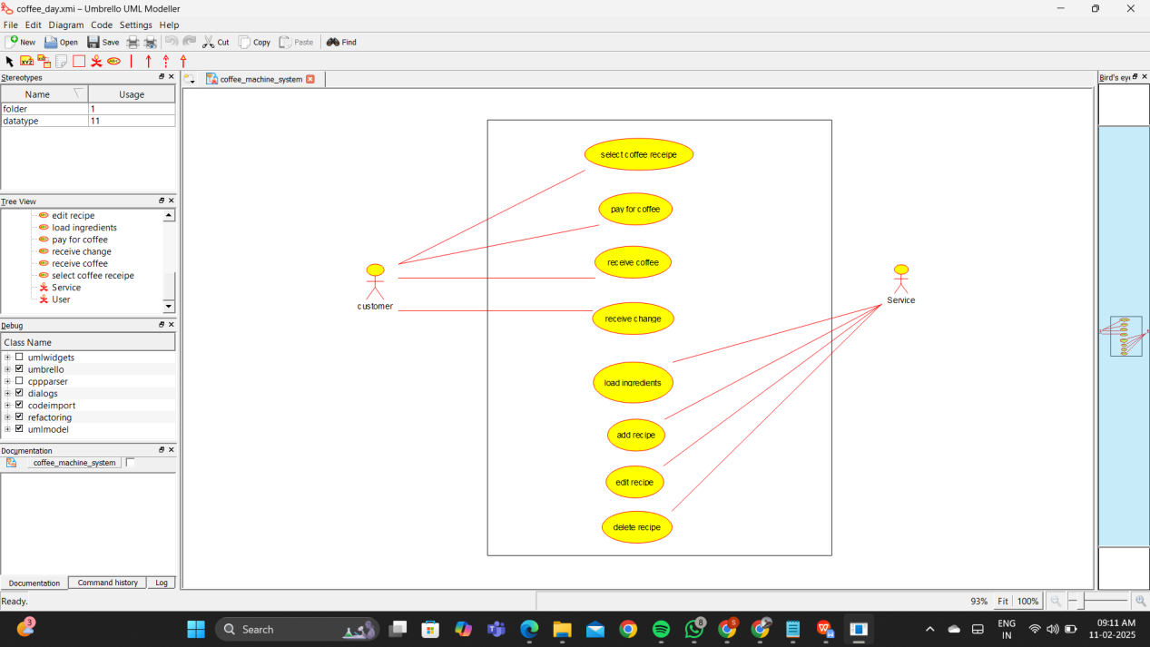

Result:

Thus the UML diagram has been implemented successfully.